Test plan:
Test No. | Purpose of Test | Expected Outcome | Test Data
1 | Check all the nav bar buttons work | Click on each button on the nav bar and it should take you to the correct page | Nav bar or website
2 | All pages should be using same fonts and colours for text | Check each page for font and text consistency | Each page of website
3 | The log in function will allow user to log in | The login will work and display the username on the nav bar | User log in using name: Greg and password 123
4 | The log in wont work if password is wrong | Error popup saying wrong password will show | Log in with password: 789
5 | Log out button will allow user to log out | User presses log out and the name will disappear from nav bar | User will log in then click log out: use loging details: greg, passoword = 123
6 | The review page will display users reviews | Open review page and see it display all users reviews | Click review page
7 | User can add a review and it will display coreclty | Click reivew page then add a review and it will display with the correct format | Click review page and add a review name: greg  Review: Devon Dive is amazing.
8 | Styleing consisetency all pages using the orange and blue style with dark blue for nav bar and footer | Check all pages for color and style consistency | Open and evaluate each page
9 | Check how the page looks on a mobile | Ensure all the page resiszes properly and looks good and legible on phones | Open website and navigate the pages on mobile device.

Test log:

Test 1: Navigation Bar Buttons
Test No.: | 1
Purpose of Test: | Check all navigation bar buttons work
Test Data: | Nav bar links on the website
Expected Outcome: | Clicking each button should take you to the correct page
Actual Outcome: | All buttons take user to correct corresponding pages
Pass/Fail: | Pass
Evidence: | 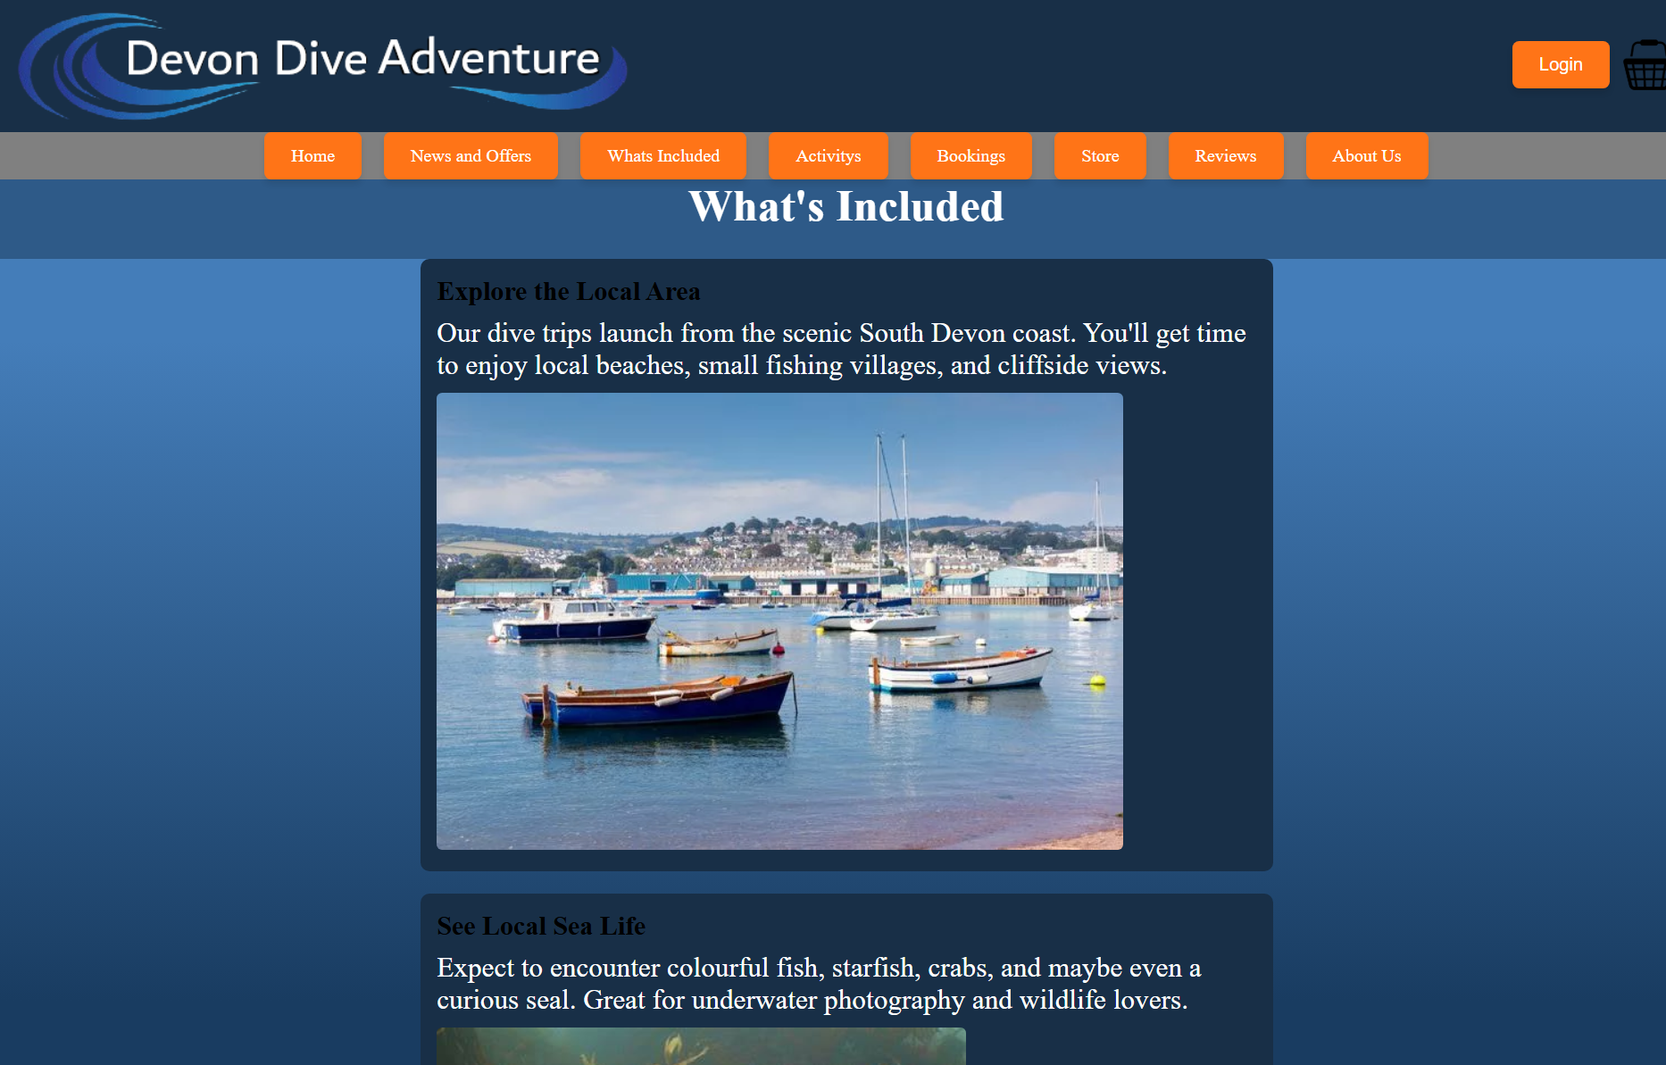

Test 2: Font & Color Consistency
Test No.: | 2
Purpose of Test: | Ensure all pages use the same fonts and colors
Test Data: | Website pages
Expected Outcome: | Fonts, text colors, and styling should be consistent across all pages
Actual Outcome: | Needs improvement almost all pages use consistent font some of the pages created buy other developers needs small work
Pass/Fail: | Needs small changes
Evidence: | This page passed   This page fails slightly diffent font and different text size  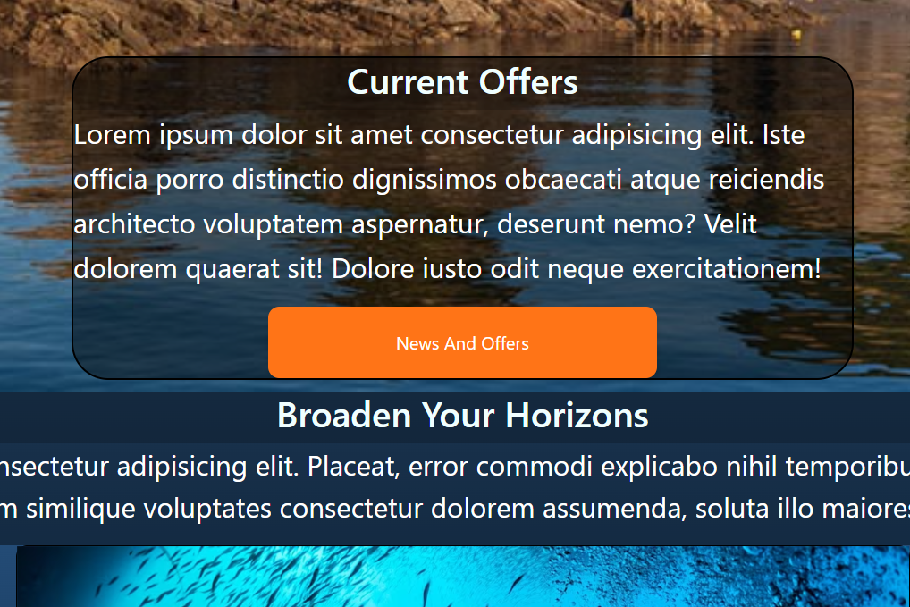

Test 3: Login Functionality
Test No.: | 3
Purpose of Test: | Verify login functionality works
Test Data: | Login with username: Greg, password: 123
Expected Outcome: | Username should display on the nav bar after login
Actual Outcome: | The username is displayed and works correctly
Pass/Fail: | pass
Evidence: | 

Test 4: Incorrect Password Handling
Test No.: | 4
Purpose of Test: | Ensure incorrect password prevents login
Test Data: | Login with username: Greg, password: 789
Expected Outcome: | Error message should display saying the password is incorrect
Actual Outcome: | asks user to try again to log in as incorrect password
Pass/Fail: | pass
Evidence: | 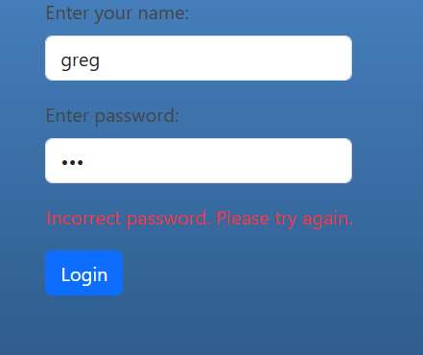

Test 5: Logout Functionality
Test No.: | 5
Purpose of Test: | Ensure log out button removes user session
Test Data: | Login (username: Greg, password: 123) and click "Logout"
Expected Outcome: | Username should disappear from the nav bar
Actual Outcome: | the button will log out the user
Pass/Fail: | pass
Evidence: | 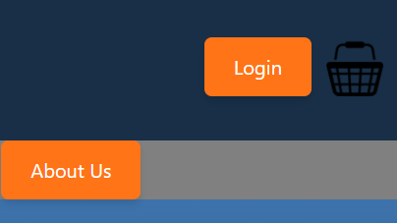

Test 6: Review Page Display
Test No.: | 6
Purpose of Test: | Verify review page displays user reviews
Test Data: | Access review page
Expected Outcome: | Reviews should be displayed properly
Actual Outcome: | All previous reviews are displayed correctly
Pass/Fail: | pass
Evidence: | 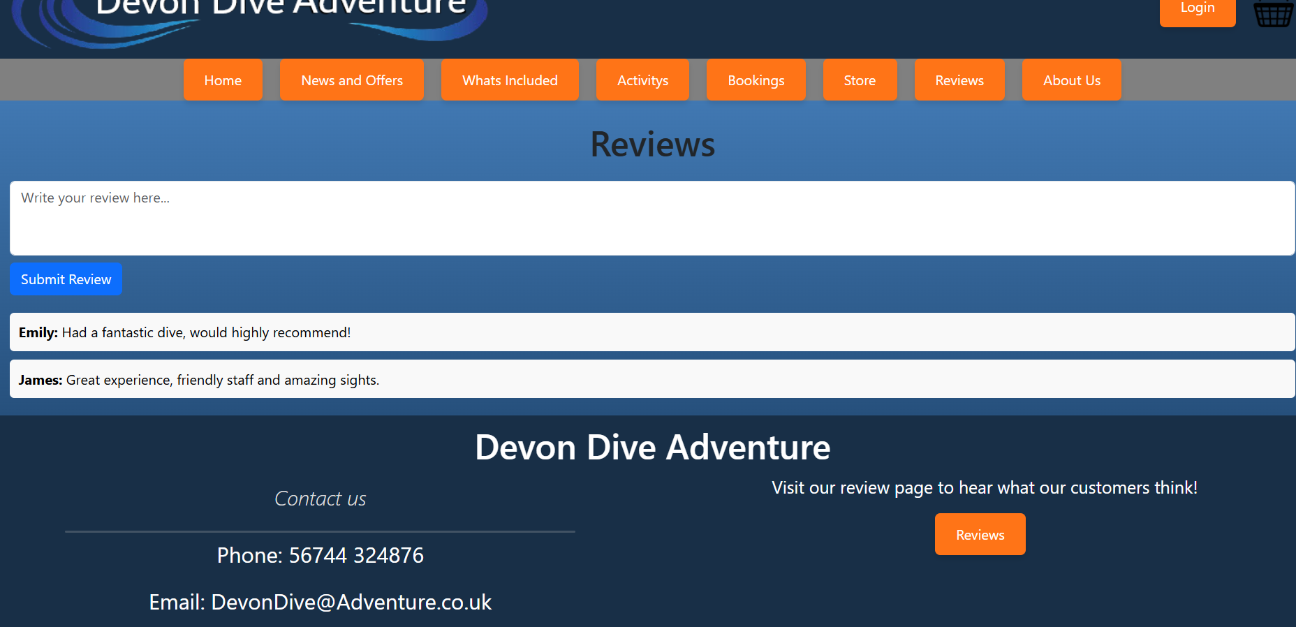

Test 7: Submitting a Review
Test No.: | 7
Purpose of Test: | Ensure users can submit a review and it displays correctly
Test Data: | Submit review as Greg: "Devon Dive is amazing."
Expected Outcome: | Review should appear correctly with the expected formatting
Actual Outcome: | Was able to add a proper review and dispalys correctly
Pass/Fail: | Pass
Evidence: | 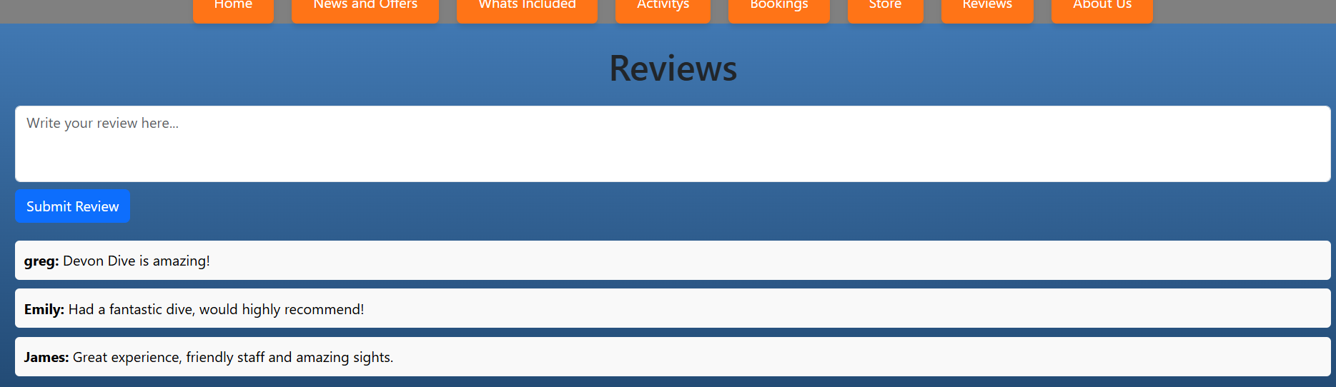

Test 8: Styling Consistency
Test No.: | 8
Purpose of Test: | Ensure all pages follow the expected style
Test Data: | Open all pages
Expected Outcome: | All pages should follow the orange and blue theme with dark blue nav bar and footer
Actual Outcome: | All pages follow the main style and themes with no exceptions
Pass/Fail: | pass
Evidence: | 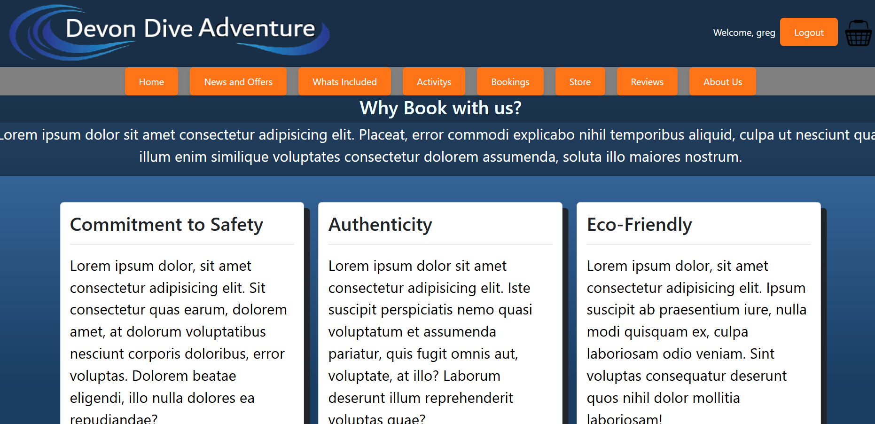

Test 9: Mobile Responsiveness
Test No.: | 9
Purpose of Test: | Check how the page looks on mobile
Test Data: | Open website on phone and navigate pages
Expected Outcome: | Site should resize properly and be legible
Actual Outcome: | It is readable and displays ok however it does not look too nice so need improvement it is all too squashed
Pass/Fail: | Fail
Evidence: | 